BLC - 3 Program:

⚠️ Important: Press Enter after each complete number, not after each digit. The blank line you see after pressing Enter is normal — the program is ready for the next number.

;=================================================================

; CIS11 - Bubble Sort Sorcerers

; Team: Bryant Martinez Fossati, Cassandra Suarez, Ryland Tolentino

; Class: CIS 11

; LC-3 Bubble Sort — Complete Implementation

; Input: User types 8 integers (0-100) at keyboard, Enter after each

; Output: 8 sorted integers displayed in ascending order on console

; Test input : 11 8 2 17 6 4 3 21

; Expected : 2 3 4 6 8 11 17 21

;

; ---- Register usage (main program) ----

; R0 = scratch / TRAP I/O parameter

; R1 = array pointer

; R2 = loop counter (outer sort / input / output)

; R3 = inner loop counter (sort)

; R4 = A[j] (current element during sort)

; R5 = A[j+1] (next element during sort)

; R6 = stack pointer (dedicated; never reused for other purpose)

; R7 = return address (set by JSR, restored by RET)

;

; ---- Subroutines ----

; INPUT_NUM — reads one decimal integer from keyboard (ASCII->binary)

; PRINT_NUM — prints one decimal integer to console (binary->ASCII)

;

; ---- Memory layout ----

; x3000+ : program code + constants

; ARRAY : 8-word array (input values / sorted result)

; STACK : 20-word software stack (grows downward)

; STTOP : stack pointer initialised here (empty-stack sentinel)

;=================================================================

.ORIG x3000

;-----------------------------------------------------------------

; INITIALIZATION — load stack pointer

;-----------------------------------------------------------------

MAIN LEA R6, STTOP ; R6 = stack pointer (points above stack)

;-----------------------------------------------------------------

; INPUT PHASE — read 8 integers from keyboard into ARRAY

;-----------------------------------------------------------------

LEA R1, ARRAY ; R1 = pointer to start of array

AND R2, R2, #0

ADD R2, R2, #8 ; R2 = input count = 8

IN_MAIN BRnz SORT_START ; if count <= 0, done reading

JSR INPUT_NUM ; call subroutine — result returned in R0

STR R0, R1, #0 ; store entered value into array[i]

ADD R1, R1, #1 ; advance array pointer to next slot

ADD R2, R2, #-1 ; decrement remaining count

BRnzp IN_MAIN ; loop back for next number

;-----------------------------------------------------------------

; SORT PHASE — in-place bubble sort, n=8 fixed, 7 passes

;-----------------------------------------------------------------

SORT_START

AND R2, R2, #0

ADD R2, R2, #7 ; R2 = outer counter = n-1 = 7

OUTER BRnz PRINT_START ; if outer counter <= 0, sorting done

LEA R1, ARRAY ; reset array pointer to start each pass

ADD R3, R2, #0 ; R3 = inner counter for this pass

INNER BRnz NXTPASS ; if inner counter <= 0, this pass done

LDR R4, R1, #0 ; R4 = A[j] — load current element

LDR R5, R1, #1 ; R5 = A[j+1] — load next element

; Compute A[j] - A[j+1] via 2's complement subtraction

NOT R0, R5 ; R0 = bitwise NOT of A[j+1]

ADD R0, R0, #1 ; R0 = -A[j+1]

ADD R0, R4, R0 ; R0 = A[j] - A[j+1] (sets condition codes)

BRnz NOSWAP ; if A[j] <= A[j+1], no swap needed

; Swap A[j] and A[j+1]

STR R5, R1, #0 ; M[j] = old A[j+1]

STR R4, R1, #1 ; M[j+1] = old A[j]

NOSWAP ADD R1, R1, #1 ; advance pointer to next pair

ADD R3, R3, #-1 ; decrement inner counter

BRnzp INNER ; next comparison

NXTPASS ADD R2, R2, #-1 ; decrement outer counter

BRnzp OUTER ; next pass

;-----------------------------------------------------------------

; OUTPUT PHASE — print 8 sorted values to console

;-----------------------------------------------------------------

PRINT_START

LEA R1, ARRAY ; R1 = pointer to sorted array

AND R2, R2, #0

ADD R2, R2, #8 ; R2 = print count = 8

PR_MAIN BRnz DONE ; if count <= 0, done printing

LDR R0, R1, #0 ; R0 = next sorted value

JSR PRINT_NUM ; call subroutine to print it

AND R0, R0, #0

ADD R0, R0, #10 ; R0 = x000A = newline

TRAP x21 ; OUT: newline after each number

ADD R1, R1, #1 ; advance array pointer

ADD R2, R2, #-1 ; decrement count

BRnzp PR_MAIN ; loop

DONE TRAP x25 ; HALT

;=================================================================

; SUBROUTINE: INPUT_NUM

;

; Reads one decimal integer from the keyboard (range 0 to 100).

; Uses TRAP x23 (GETC) to read one character at a time.

; Accepts digit characters '0'-'9'; echoes each digit via TRAP x21.

; Any non-digit (Enter, CR, space) terminates input.

; Multi-digit assembly: total = total * 10 + digit

; Multiply by 10 uses shift-add: total*8 + total*2

;

; Input : none

; Returns: R0 = binary integer value entered by user

; Saves : R1, R2, R3, R7 (pushed on stack; popped before return)

;=================================================================

INPUT_NUM

; --- PUSH: save registers this subroutine will modify ---

ADD R6, R6, #-1

STR R7, R6, #0 ; push return address (TRAP x23 overwrites R7)

ADD R6, R6, #-1

STR R1, R6, #0 ; push R1

ADD R6, R6, #-1

STR R2, R6, #0 ; push R2

ADD R6, R6, #-1

STR R3, R6, #0 ; push R3

AND R1, R1, #0 ; R1 = running total = 0

DGTLOOP TRAP x23 ; GETC: read one character into R0

; ---- Check lower bound: char >= '0' (x30 = 48) ----

LD R3, NEG_ZERO ; R3 = -48

ADD R2, R0, R3 ; R2 = R0 - '0'

BRn IN_DONE ; if R2 < 0: character is below '0' — stop

; ---- Check upper bound: char <= '9' (x39 = 57) ----

ADD R3, R2, #-9 ; R3 = (R0 - '0') - 9

BRp IN_DONE ; if R3 > 0: character is above '9' — stop

; ---- Valid digit: echo it so user sees what they typed ----

TRAP x21 ; OUT: echo the digit character (R0 unchanged)

; ---- Accumulate: R1 = R1 * 10 + digit ----

; R2 holds the digit value (0-9)

; R1 * 10 = (R1 * 8) + (R1 * 2)

ADD R3, R1, R1 ; R3 = R1 * 2

ADD R3, R3, R3 ; R3 = R1 * 4

ADD R3, R3, R3 ; R3 = R1 * 8

ADD R3, R3, R1 ; R3 = R1 * 9

ADD R3, R3, R1 ; R3 = R1 * 10

ADD R1, R3, R2 ; R1 = R1*10 + digit

BRnzp DGTLOOP ; read next digit

IN_DONE ADD R0, R1, #0 ; move result from accumulator R1 into R0

; --- POP: restore registers in reverse push order ---

LDR R3, R6, #0

ADD R6, R6, #1 ; pop R3

LDR R2, R6, #0

ADD R6, R6, #1 ; pop R2

LDR R1, R6, #0

ADD R6, R6, #1 ; pop R1

LDR R7, R6, #0

ADD R6, R6, #1 ; pop return address

RET ; return to caller

;=================================================================

; SUBROUTINE: PRINT_NUM

;

; Prints one integer (range 0 to 100) as decimal ASCII digits.

; Performs binary-to-ASCII conversion using repeated subtraction:

; Value 100 ? special case, prints "100"

; Value 10-99 ? extract tens via repeated subtraction of 10,

; remainder is ones digit

; Value 0-9 ? print single digit

; Each digit sent to console with TRAP x21 (OUT) after adding x30.

;

; Input : R0 = integer to print (0 to 100)

; Returns: nothing (side effect: characters printed to console)

; Saves : R0, R1, R2, R3, R7 (pushed on stack; popped before return)

;=================================================================

PRINT_NUM

; --- PUSH: save registers this subroutine will modify ---

ADD R6, R6, #-1

STR R7, R6, #0 ; push return address

ADD R6, R6, #-1

STR R0, R6, #0 ; push R0

ADD R6, R6, #-1

STR R1, R6, #0 ; push R1

ADD R6, R6, #-1

STR R2, R6, #0 ; push R2

ADD R6, R6, #-1

STR R3, R6, #0 ; push R3

ADD R1, R0, #0 ; R1 = working copy of value to print

; ---- Special case: value == 100 ----

LD R2, NEG_100

ADD R2, R1, R2 ; R2 = value - 100

BRnp CHK_TENS ; if result != 0, value is not 100

; value IS 100 — print '1', '0', '0'

LD R0, ASCII_ONE

TRAP x21 ; print '1'

LD R0, ASCII_ZERO

TRAP x21 ; print '0'

TRAP x21 ; print '0'

BRnzp PR_DONE

; ---- Two-digit check: value >= 10 ? ----

CHK_TENS

LD R3, NEG_TEN

ADD R3, R1, R3 ; R3 = value - 10

BRn ONE_DIGIT ; if value < 10, go to single-digit path

; ---- Two-digit path: extract tens and ones ----

AND R2, R2, #0 ; R2 = tens digit = 0

TENSLOOP

LD R3, NEG_TEN

ADD R3, R1, R3 ; R3 = R1 - 10

BRn TENS_DONE ; if R1 < 10, done extracting tens

ADD R1, R3, #0 ; R1 = R1 - 10 (subtract one ten)

ADD R2, R2, #1 ; tens digit++

BRnzp TENSLOOP

TENS_DONE

; R2 = tens digit (1-9), R1 = ones digit (0-9)

LD R0, ASCII_ZERO

ADD R0, R0, R2 ; R0 = '0' + tens (binary-to-ASCII)

TRAP x21 ; OUT: print tens digit

LD R0, ASCII_ZERO

ADD R0, R0, R1 ; R0 = '0' + ones (binary-to-ASCII)

TRAP x21 ; OUT: print ones digit

BRnzp PR_DONE

; ---- Single-digit path: value 0-9 ----

ONE_DIGIT

LD R0, ASCII_ZERO

ADD R0, R0, R1 ; R0 = '0' + value (binary-to-ASCII)

TRAP x21 ; OUT: print the digit

PR_DONE

; --- POP: restore registers in reverse push order ---

LDR R3, R6, #0

ADD R6, R6, #1 ; pop R3

LDR R2, R6, #0

ADD R6, R6, #1 ; pop R2

LDR R1, R6, #0

ADD R6, R6, #1 ; pop R1

LDR R0, R6, #0

ADD R6, R6, #1 ; pop R0

LDR R7, R6, #0

ADD R6, R6, #1 ; pop return address

RET ; return to caller

;-----------------------------------------------------------------

; CONSTANTS — used by LD instruction (PC-relative addressing)

;-----------------------------------------------------------------

NEG_ZERO .FILL xFFD0 ; -48 (negation of ASCII '0' = x0030)

NEG_TEN .FILL xFFF6 ; -10

NEG_100 .FILL xFF9C ; -100

ASCII_ZERO .FILL x0030 ; '0' (ASCII base for digit conversion)

ASCII_ONE .FILL x0031 ; '1' (used for printing 100)

;-----------------------------------------------------------------

; DATA

;-----------------------------------------------------------------

ARRAY .BLKW 8 ; 8-word array for input values / sorted result

;-----------------------------------------------------------------

; STACK — software stack, grows downward

; Each PUSH: ADD R6,R6,#-1 then STR Rx,R6,#0

; Each POP: LDR Rx,R6,#0 then ADD R6,R6,#1

; Max stack depth = 20 words (INPUT_NUM uses 4, PRINT_NUM uses 5)

;-----------------------------------------------------------------

.BLKW 20 ; 20-word stack buffer

STTOP .FILL x0000 ; stack pointer initialised to this address

.END

Testing Pictures:
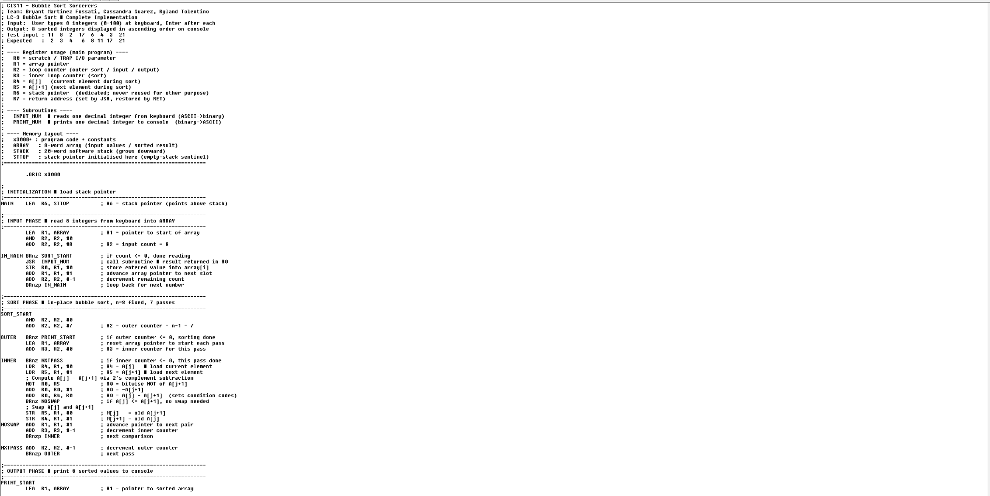
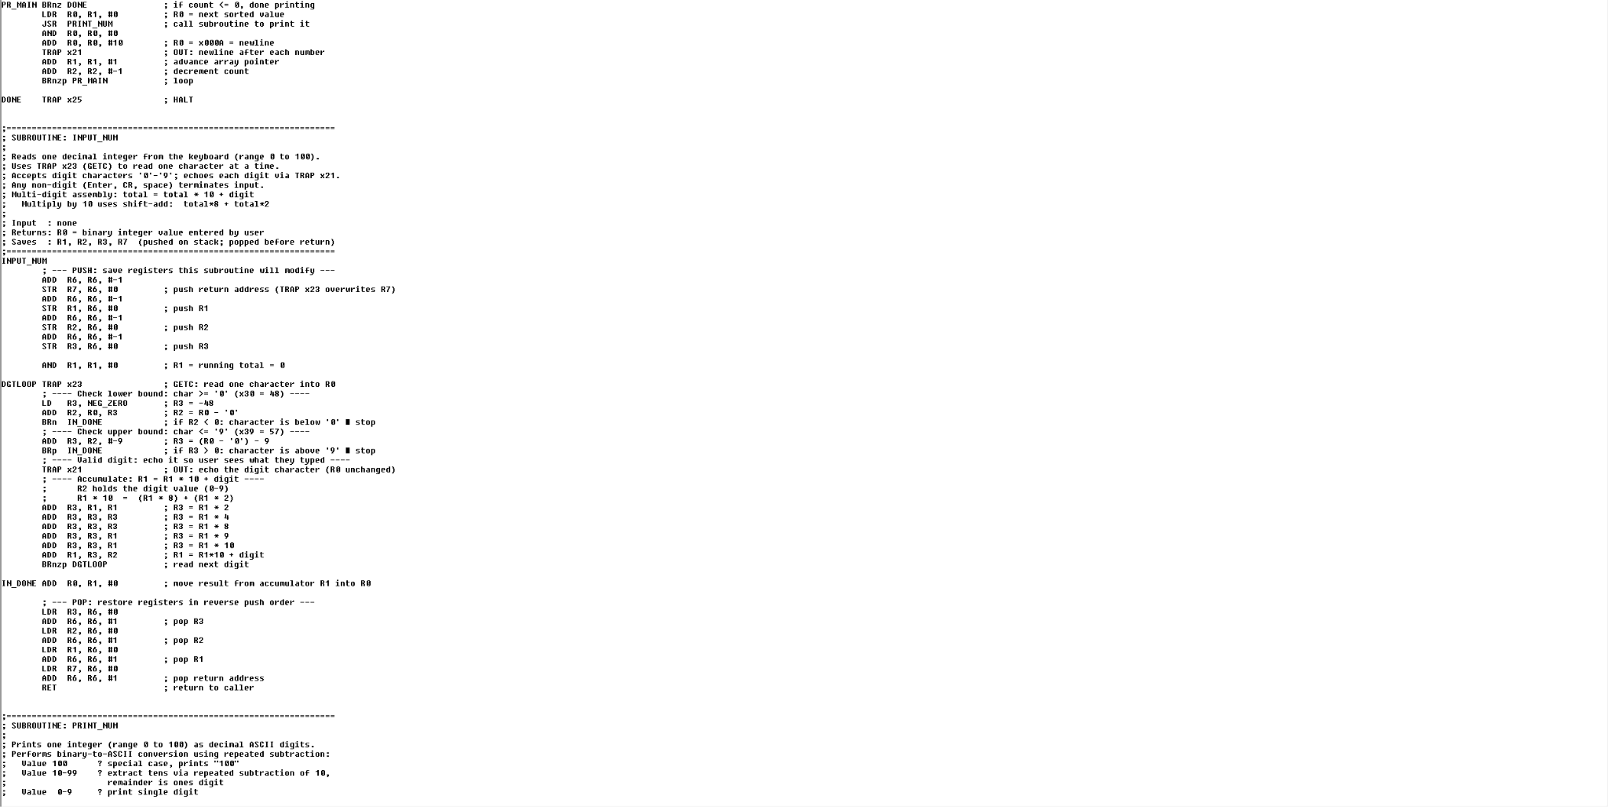
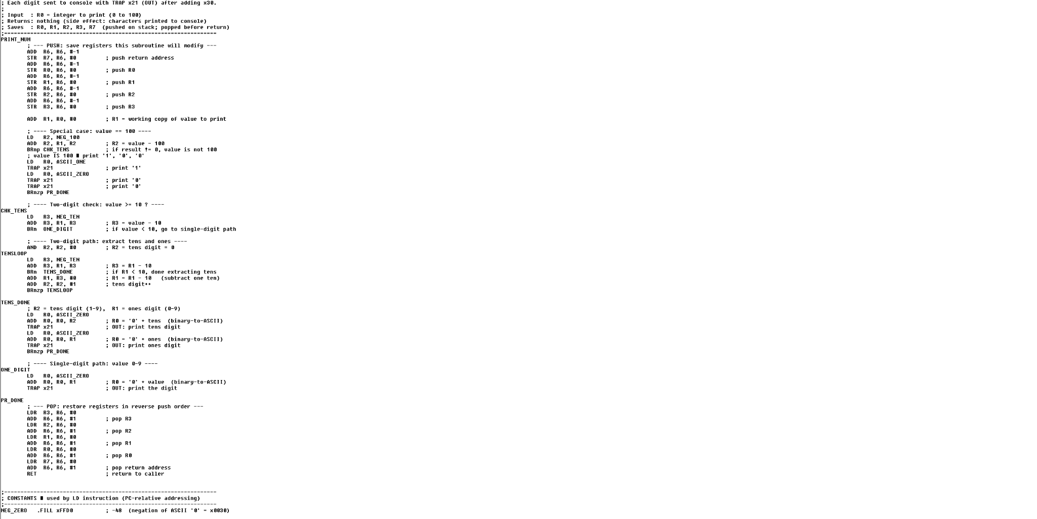
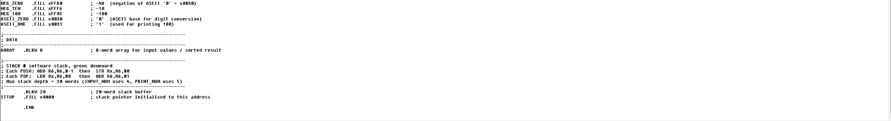

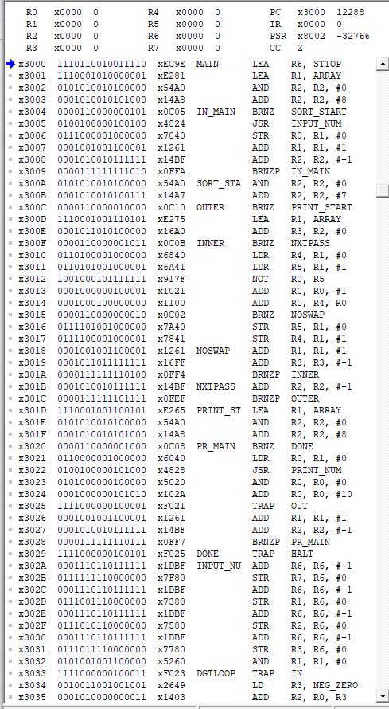
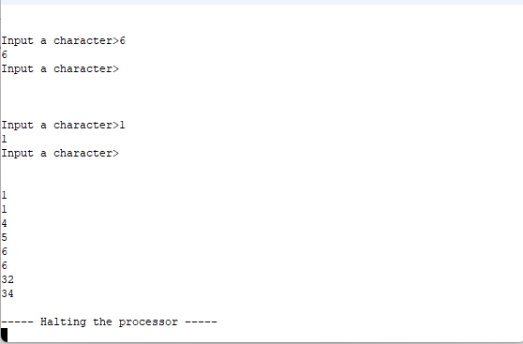

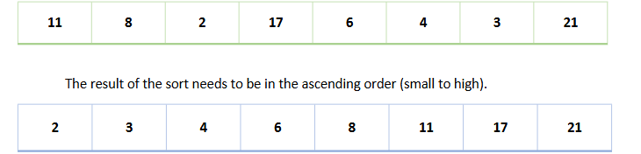
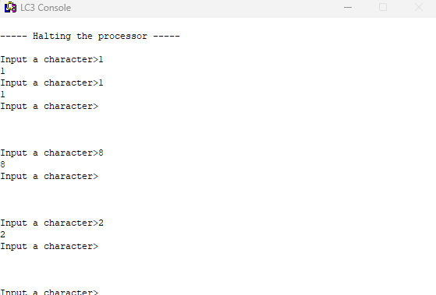
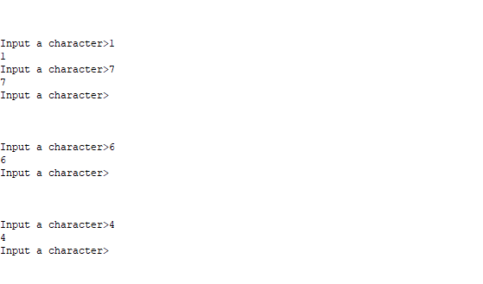
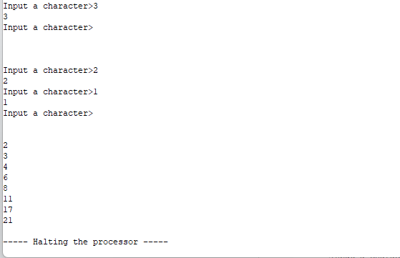

Though our program allows us to do exactly what a bubble sort is supposed to, it does fall under certain problems such as the inputting of the program itself.

We will still get the right output in this different way. It could be modified to make it more user friendly but this will do.

As you can see in the examples, to get a number with two digits we input the numbers to combine them and then press enter to submit it to the program for the output.

The numbers are entered in any order and the program rearranges them into ascending order, confirming the bubble sort works correctly

